Love Letters to Myself: Reframing, Revising and Retelling Negative Thoughts - A Twine Project

Author: Erin Chu
Target Grade: PHE Grade 5/6/7 – Social-Emotional Learning
Created: August 8, 2022
Edited: November 20, 2022, by Chris Kerslake
Usage Permissions: The author has given permission to use this lesson plan and project files in your own classroom. Sharing is permitted, but not resale. Attribution is appreciated, but not required.
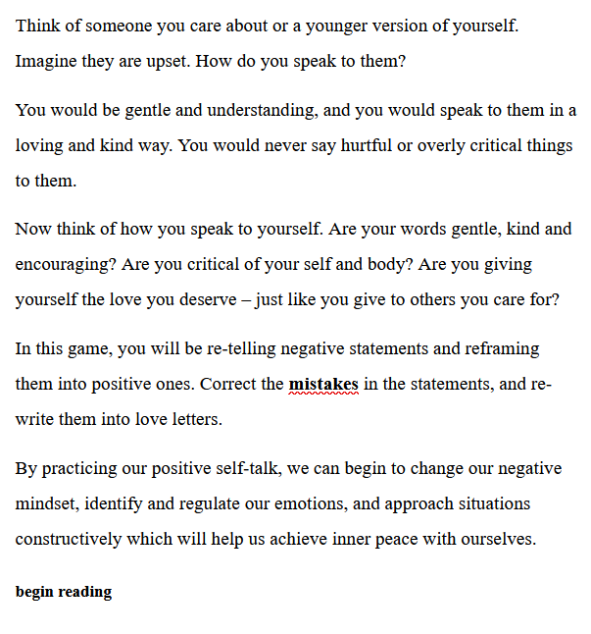 | 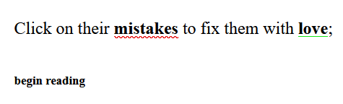  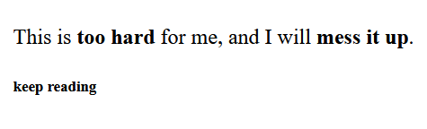  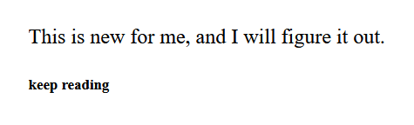
Contents
Section 1: BC Curriculum Connections 3
Section 2: Learning Plan Considerations 4
Section 3: Assessment Plan 6
Rubric 7
Section 4: Teaching Plan 9

Title: | Love Letters to Myself: Reframing, Revising and Retelling Negative Thoughts - A Twine Project
Author: | Erin Chu
Grade/Subject: | PHE Grade 5/6/7 - Social-Emotional Learning
Teacher’s Example | Click link and download:  https://erinchu.github.io/
Summary | For this lesson, students will use Twine to create an interactive virtual space to retell hateful, negative phrases into something positive and constructive. In the form of negative statements, students will be correcting the mistakes and re-writing them into love notes. Then, they will have the opportunity to create their own. Using Twine, students will learn to retell, reframe and revise negative self-talk by creating an interactive experience that combines curricular skills from PHE, ELA as well as in ADST. This lesson plan covers BC’s PHE and ELA curriculum. The aim for this lesson is to provide situations where students can practice retelling hateful words into love notes to themselves. We are often our worst critic, therefore it’s important to remind students to be kinder to themselves.
Learning Outcomes:  Bloom’s Taxonomy | By the end of this lesson, students will be able to reframe, revise and re-tell negative thoughts into positive, constructive ones. Students will build, design and create an interactive story using Twine. The purpose of using Twine is to see how we can quickly change our thoughts if we allow our mind to do it. When we can reframe our thoughts and see situations in a different light, we will begin to feel peace from within and be able to assess the situation rationally.  The goal is to teach both the student and player to see the different ways we can challenge and reframe our thinking in a difficult situation. Students will be using the basic building blocks and simple HTML and CSS on Twine to create their individual interactive story.
Sources Reference: | Retelling  https://xurxe.itch.io/re-telling By Xurxe Toivo García  Coding Resources  https://twinery.org/cookbook/css/storyformats/harlowe.html  https://twinery.org/forum/discussion/5292/jump-to-random-passage  https://twinery.org/questions/63/how-to-randomize-next-passage
Required Technology, Resources, and Materials | Twine: https://twinery.org  Laptop or iPad  Wi-Fi connection
Files: | Twine Template: Love Letters to Myself.html  Student Worksheet: Love Letters to Myself - Worksheet.pdf  Rubric: Love Letters to Myself - Rubric.docx  Slides (PDF): Love Letters to Myself - Twine Project - Slides.pdf

Section 1: BC Curriculum Connections

BC Curriculum Links (URLs)
- https://curriculum.gov.bc.ca/curriculum/physical-health-education/5/core
- https://curriculum.gov.bc.ca/curriculum/physical-health-education/6/core
- https://curriculum.gov.bc.ca/curriculum/physical-health-education/7/core

BC Big Idea
- Personal choices and social and environmental factors influence our health and well-being.

BC Curricular Competencies
- Describe and assess strategies for promoting mental well-being, for self and others
- Describe and assess strategies for managing problems related to mental well-being and substance use, for others
- Explore and describe strategies for managing physical, emotional, social changes during puberty
- Explore and describe how personal identities adapt and change in different settings & situations
- Describe and apply strategies for developing and maintaining healthy relationships
- Describe and apply strategies that promote a safe and caring environment

BC Content Competencies
- physical, emotional, and social changes that occur during puberty and adolescence
  - Physical: how students’ bodies are growing and changing during puberty and adolescence.
  - Emotional: how students’ thoughts and feelings might evolve or change during puberty and adolescence.
  - Social: how students interact with others and how their relationships might evolve or change during puberty and adolescence.
- influences on individual identity, including sexual identity, gender, values, and beliefs
  - a component of a person’s identity that reflects his or her sexual self-concept.

Infusing Aboriginal Education and Indigenous ways of knowing, doing, and being
- Learning involves patience and time.
  - Self doubt and negative thoughts can really hold us back if we don’t have them under control. Everyone has negative thoughts from time to time, and it is important for children to develop a sense of self-awareness to turn a negative mindset into something positive.
- Learning requires exploration of one‘s identity.
  - Talking about feelings and emotions are part of human nature and are important in building social emotional skills such as empathy and self-awareness. Reflecting on our own feelings and being aware of our emotions makes it easier to understand why we react the way we do, and it also allows us to support others the way they need to be supported.
- Learning ultimately supports the well-being of the self, the family, the community, the land, the spirits, and the ancestors.
  - Students will begin by thinking of situations or statements to help them build awareness of these thoughts. By building awareness, it allows students to challenge and refute negative thoughts and recognize what they are thinking may not be the most helpful for them.

Section 2: Learning Plan Considerations

Technology Benefits
Using Twine, students will learn to retell, reframe and revise negative self talk by creating an interactive experience that combines curricular skills from PHE, ELA as well as in ADST. Twine allows students to make connections between text and links that show relations between passages. Using Twine will allow students to practice storytelling tools and computing skills at the same time. This interface allows students to visually map out their storyline, as there is a visual storyboard with all the passages, links and connections. Students will practice basic HTML codes and CSS to create their interactive story. One of the functions we will be using in this project is text reveal. The purpose of using Twine in this lesson is to see how quickly we change our thoughts if we allow our mind to do it. When we can reframe our thoughts and see situations in a different light, we will begin to feel peace from within and be able to assess the situation rationally. The benefit of using this technology is experimenting with different types of storytelling in a PHE unit.

Howland’s Criteria for Meaningful Learning:
This project is meant to be personal to students, therefore it would be intentional and meaningful. Students can reflect on their own lives and the world around them and critique the thoughts they may have heard and how they responded to them. For this project, students are learning with technology rather than just from technology by creating and designing their own interactive projects from start to finish. Students will make selective, intentional decisions to map out their story in a way that is comprehensive and easy to follow for the player. For example, they will be choosing selective text and changing it into a different phrase. This lesson incorporates play and collaborations, both that are part of Howland’s criteria of meaningful learning. In addition, the lesson also provides a clear guideline and rubric to follow, however students still have autonomy and creative freedom to create their story as there are options to add greater depth and interactivity. The learning is meaningful as they are able to share their projects with other students when completed. At the end of the project, students will also reflect on the activity by completing a journal response.

Could this lesson be done without technology?
Yes. This can be done without technology as students can still complete the worksheets [Section 4], however it will lose the interactivity part where the project feels like a simulation.

Prior Knowledge/Experience
The prior knowledge expected for this project is the ability to creatively write and reflect. Students are also expected to have used Twine before in class, so they have basic knowledge with how to link passages together “[[ & ]]” as well as using other basic building blocks within Twine.

Potential Barriers to Success & Student Accommodations

- If students have trouble hearing or seeing: Encourage students to sit closer, and the teacher can project lessons on screen.
- If students are not strong typists: it can be difficult for them to create a story on their own. A solution for this is to give these students a separate worksheet that just focuses on a few main ideas. Students should still use this opportunity to practice typing, but the teacher can reduce students' anxiety with typing if they can pre-load the amount of text needed to be typed that is in front of them.
- If the material is too sensitive for some students: Students can choose from a list of negative statements that the teacher provides and recreate positive, constructive statements for their project. Students can also reflect and do more research on different societal standards that may lead to a negative mindset for others.
- If students have difficulty being on track and staying on task: Students are expected to follow along given the time they have or else, they may fall behind. Check in with students once in a while. A solution to this is asking students who are finished to help those who may still be stuck.
- If students are overwhelmed with multiplicative options: Twine is text based so it may be difficult for a few learners who are more visual learners. Prompt students to follow their web worksheet as a guide and print out screenshots of a step by step to Twine to follow.
- If there are not enough individual devices: In this case, students can partner up with a peer and complete the project together.
- If students have difficulty getting started: Provide them with more specific prompts and cater them towards the learner’s interests. Work with them closely and provide positive feedback and encouragement.
- For English Language Learners: The teacher will be using a clear voice, hand gestures and actions to demonstrate the activity.
- If the project is taking longer than it is planned: This project is expected to take 1-3 sessions. If it is taking too long in class, the teacher can explain that students bring a USB, or they can email their link for their project to be accessed at home. The students have already experienced step by step on how Twine works in class, therefore they can add more to it and continue to work on it at home.

Student Enrichment
Students who finish early and complete their project can extend their learning by creating longer passages and more links. Students can also add definition links to specific words, and either share the definition of the word or create their new definition.

Another extension to this project using Twine is to encourage students to create statements that they may not relate to. This could be gender norms, gender identity, assumptions, stereotypes, and negative claims associated with body images, gender, race, ethnicity or culture.

Section 3: Assessment Plan

Formative Assessment Plan:
- Teachers will go over students Reframing Negative Thoughts worksheets before students start on their project to make sure they are on the right track
- Teacher will pause during slides for the coding portion and check understanding
- Teacher will ask questions before, during and after the lesson [See Section 4]
- Teachers will observe students during the lesson and activity as well as their ability to follow instructions to show their understanding.
- Teacher will engage with students and checking for their genuine understanding
- Observation of students physical and emotional behaviors when coding

Summative Assessment Plan:
The completed project will be evaluated based on the rubric below. Students will save the file and email/upload it so the teacher has access to see the students' Twine story.

Rubric
Achievement Indicators | 1 | 2 | 3 | Scale
Variety and Creativity  - How creative students are.  - What elements did they add to make the story interactive and an enjoyable educational experience for the reader?  - Writing is meaningful and personalized. | - Student is not creative in their interactive story.  - Student did not add any codes to engage with reader. | - Student used some tools within Twine to be creative and add some depth.  - Text is somewhat interactive.  - Reader is somewhat engaged. | - Student used a variety of tools within Twine creatively to engage readers that adds greater depth and interactivity.  - Text is interactive and integrated meaningfully. | 1 2 3
Organization/Connection  - Clear connection between passages and links.  - Represent and communicate ideas and findings in a variety of ways.  - Hyperlinks and hidden passages make sense.  - Students show understanding. | - Student is beginning to understand Twine, using minimal passage links.  - The student created less than 5 passages or links.  - Student did not produce complete sentences or paragraphs.  - There is little to no connection between passages. | - Student wrote passages using full sentences.  - Student uses many components in Twine and created more than 5 passages and links.  - Student wrote complete sentences but only some connection between passages. | - Student creatively uses all elements of Twine, an interactive, informational writing piece and remained on topic throughout the whole piece.  - The student created more than 10 passages and links.  - Student writing is easy for the reader to follow.  - All the passages are connected coherently. | 1 2 3
Writing  - Includes an introduction and end page explaining the game.  - Composed written pieces using appropriate, purposeful writing style for task given.  - Understand elements of creative writing.  - Student’s ability to use accurate grammar when writing interactive story. | - Student did not include an introduction/ending page to their story.  - Student did not produce complete sentences or paragraphs.  - Student did not use appropriate grammar, or the majority of the piece is unreadable. | - Student included an introduction and ending.  - Student wrote passages in full sentences that used some appropriate grammar.  - Story is easy to follow.  - Student uses many components in Twine and create more than 5 passages and links. | - The student included a clear introduction with instructions on how to play the game.  - An ending page is also included.  - Student used appropriate and purposeful writing to tell their story.  - Student used appropriate grammar throughout the whole interactive story and wrote more 10+ passages in depth. | 1 2 3
BONUS  - Change background or text color into their Twine project.  - Students can receive up to 3 points if they edit their CSS. | - Student did not use or unsuccessfully used the StyleSheet. | - Student experimented with CSS using the teacher's guide.  - There are a few errors. | - Student successfully changed the background and text using the StyleSheet with no errors. | 1 2 3
Score |  |  |  | /9

Student Self-Reflection:
After the lesson, student will complete their personal reflection journals
- How did you re-write the love letters?
- How did you choose what passages to include?
- What is the most meaningful to you when creating this Twine story?
- How do you feel about creating this project?
- Why is it important to reframe negative thoughts?
- Why is this project important?
- What did you learn from this project?
- What will you take away?

About using Twine:
- What was challenging for you? How did you overcome the challenge?
- What mistakes did you make? How did you fix those mistakes?
- Did you develop any strategies to help you?
- What did you notice about designing the interactive story?
- How did you feel about using CSS?
- What new information did you discover?

Section 4: Teaching Plan

Setup
Time | Teacher Does + Students Do
10 mins | Prior to class:  Set up class, collect devices required for the activity  Review the last lesson about identifying emotions and replacing recurring negative thoughts into constructive, positive thoughts.  Students are expected to have completed their Reframing Negative Thoughts organizer worksheet before the lesson. [Worksheet uploaded on Canvas].  - Write down the situation, event, or inner self-talk.  - Write down one of your recurring negative thoughts.  - Write down the positive thought that you will use to replace your negative thought.  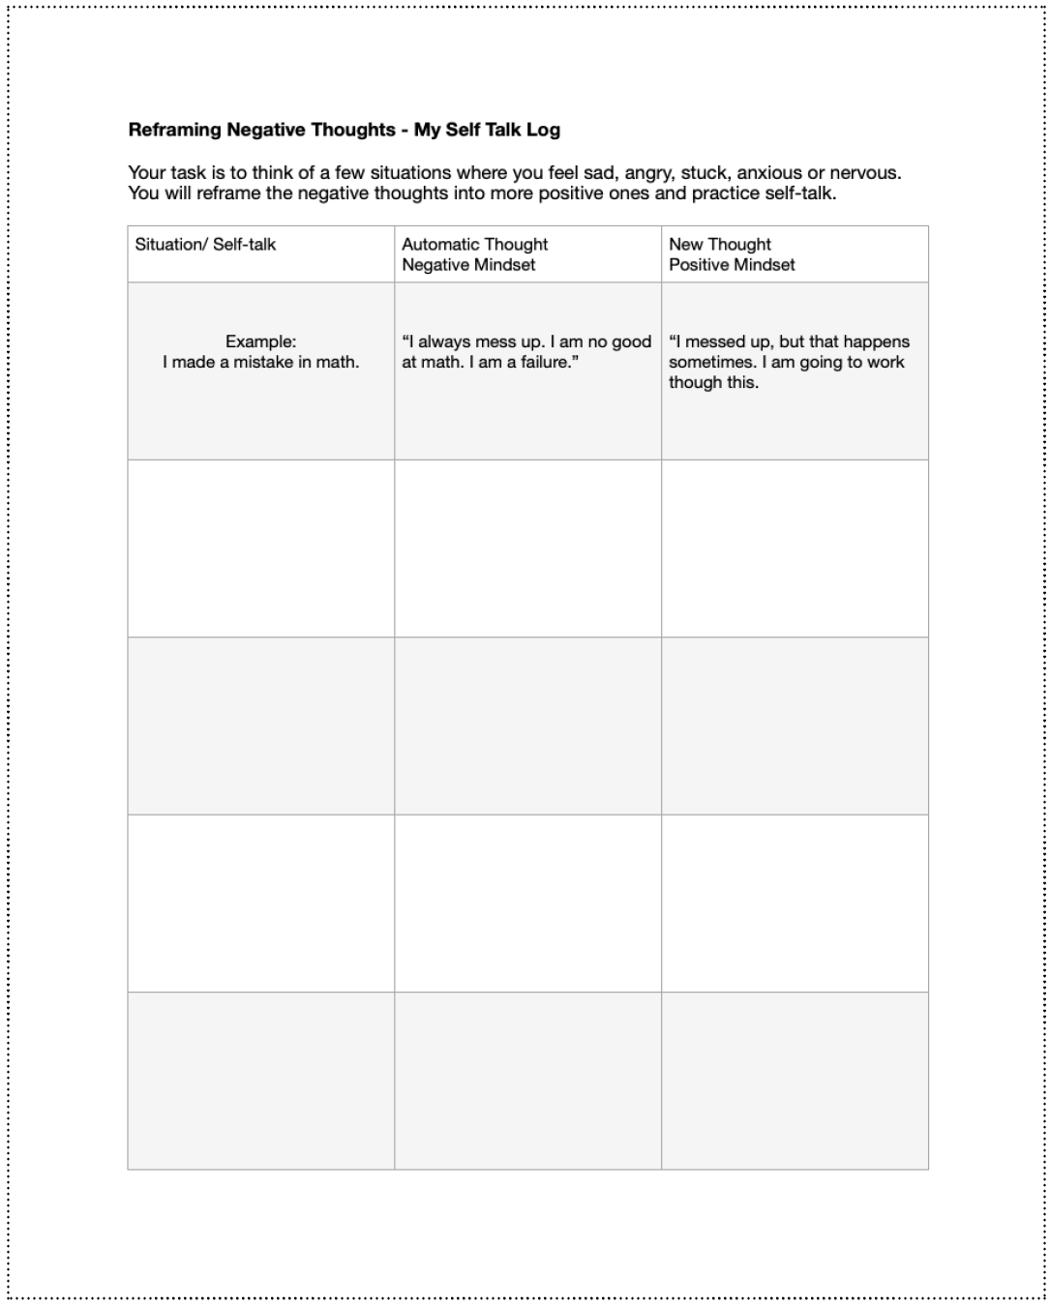  Before students begin exploring Twine, the teacher reviews student knowledge about Twine (as previously taught throughout the lesson) as a class discussion.

Lesson [ 2 - 3 sessions, 1 hour each]

Lesson Plan: Teacher Does + Student Do
PART 1: Introduce Project and Purpose
Discuss with class about all that we have been learning about how to identify emotions when we are feeling angry, sad or anxious. We also explored how to reframe our thinking when we are having negative thoughts.

Hook
- Write a few statements on the board that are considered “negative self-talk”.
- Ask students:
  - Think of someone you care about or a younger version of yourself. Imagine they are upset. How do you speak to them?
  - You would be gentle and understanding, and you would speak to them in a loving and kind way. You would never say hurtful or overly critical things to them.
  - Now think of how you speak to yourself. Are your words gentle, kind and encouraging? Are you giving yourself the love you deserve – just like you give to others you care for?
- Ask students to take out their worksheets where they practiced reflecting on their self thoughts from last class. Explain that we will now be using Twine to create an interactive story using the statements.
- Play along with students’ example story: https://erinchu.github.io/

During the game, ask students:
- Pay attention to the links and connections between the passages. How are the passages connected? How did I ask the questions?
- What was interactive about this story?
- How was the flow of the story? Was it easy to read?

PART 2: Twine Lesson and Teacher Demonstration (30 min)
Now, students will follow along with the teacher as they go through a tutorial with Twine.

- Open Twine: https://twinery.org/
- Click Story > “+ New”. A pop up will appear. Give it a name to begin with. This can be changed later too.
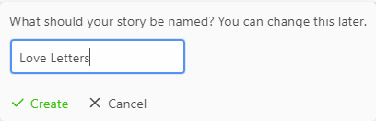
- On the storyboard, there will be one passage. This is your starting page, where the first link can be made. In this passage, you would want to write an introduction to your story that introduces the activity. Here is an example.
- To make a link, we will need to add enclosing square brackets “[[ & ]]” on a word. This will create a link to a new passage that we can now edit and continue on with our story. Keep in mind that each new link means a new passage is formed. You will have to go to the storyboard and click on each new passage and add the text inside in order for it to link. It is important to make sure you keep the title of the passage and link the same, or else if you change the link, you might see an arrow connecting to a red X. If you see this, this means the link is not connected anymore. You will have to double check to see what part of the link is not matching.

- For each link, I made sure to add a link to connect back to this question page in case the reader wanted to continue. In the case that we want to link a passage that you want to show a different text but link to an existing passage, we will need to use the arrow sign “->” with no spaces in between.

Hidden Links
Now, for the most important part, we will be creating hidden links that allow part of the text to be hidden.
- The placement of the brackets ((, quotations “” and square brackets [] are extremely important. Make sure there are no spaces in between other than the text.

- We would place the text we want to show in the blue text inside the quotation marks, and the hidden text that will be revealed after the initial text is shown.

- To make multiple entry points for the link, we would use the same format throughout our passage. This step can be repeated as many times as needed.

- When a link is created, the text will show up bold. This will let the player know that the text needs to be changed. Encourage students to change styles or text colors if attainable. A more detailed guide on how to change text size, text color and underlines are at the bottom of Section 4.

- The following example below shows how I added the hidden link code to the text to create the text reveal once each bold text is clicked.

Example:
Original passage: I hate the ways my eyes look, they are so small
New passage: I love the ways my eyes look, they allow me to see the beauty in the world.

- When the code is entered correctly, the elements of text should be color coded. The brackets are purple, the link is a light green, the original text is light blue, and the text revealed inside the square bracket is black.

- Another way to do this is by clicking Macro → Links → Create a hyperlink + Reveal [the remainder of the passage].

- Now, we have the fundamental tools to create this story. We can start adding new passages to our story to make it interactive. As part of our evaluation, you are required to do 10 minimum passages. Students are encouraged to use their worksheet as a visual guide to add into your own project.
- In the last passage, there should be a link to a separate page that completes the story.
- To extend further, you can add another link to redirect the player back to the home page.

Be Creative! - Text Styles and Animations
Once students finished the skeleton of the project, encourage students to explore and get creative using Twine, such as text decoration, text styles, animation, or definitions.

- Above each textbox, there are two lines that allow you to edit your text creatively. This includes the usual bold, italics, strikethrough, size, text and background color, rotation, and even effects.

- To add effects, first highlight the text you want to add an effect to.

- Click “Styles…” This is the page where you can test out what effect you want for the text. You can preview before adding it into your story.

- The effects include static effects such as blurring, outlines, letter spacing and dynamic effects such as blinking, rumbling, shudder, swaying and more. These should be enough for you to get creative within the text itself. Here is an example on how we can add more variations to show you how you can get creative when writing your story.

- For dynamic movements, use “animations”.

- Here is an example on how we can get even more creative.
Colored underlines on specific links:
Text size
You can use numbers or percentages. Such as, (text-size: 0.7) or (text-size: 50%). When we want to change the size of a specific text in a passage, we can add a pair of square brackets [], or double brackets if it is a link [[]]

To ensure the text stays a certain color throughout, place this code at the beginning of each passage where you may be including different text styles or change of text colors.

PART 3: BONUS MARKS → Using “Story Style Sheet”
Cascading StyleSheets (CSS) are used to change the color, typeface and other parts of the story’s visual appearance. Here, we can use a simple code that can change the background and text color to the one we want.

Changing colors
https://htmlcolorcodes.com/

This link will give the HTML code for any color. Or, you can search for “Color Picker” in the search bar.

To change story colors:

To hide the right and left arrow bars:

To change the link text to look the same as the rest of the passages:
The following CSS will change the link text of all the above link types to look the same as the rest of the passage's text, even if you change the look of the overall passage text. In between the brackets, you can place the text of the color of your choice
.enchantment-link, tw-link {
color:black;
}

To change the colors of the link when the cursor hovers:
.enchantment-link:hover, tw-link:hover {
color:black;
}

All of the style sheet entries above:

Cleanup

*FREE TIME TO PLAY WITH EACH OTHERS TWINE STORIES*

The teacher will combine each student's story links into a PDF page and send to each student's email. Students will leave their link open on their computer/laptop while other students walk around and play with their peers' projects.

After the lesson, student will complete their personal reflection journals.
- How did you re-write the love notes?
- How did you choose what passages to include?
- What is the most meaningful to you when creating this Twine story?
- How do you feel about creating this project?
- Why is it important to reframe negative thoughts?
- Why is this project important?
- What did you learn from this project?
- What will you take away?

About using Twine:
- What was challenging for you? How did you overcome the challenge?
- What mistakes did you make? How did you fix those mistakes?
- Did you develop any strategies to help you?
- What did you notice about designing the interactive story?
- How did you feel about using CSS?
- What new information did you discover?

